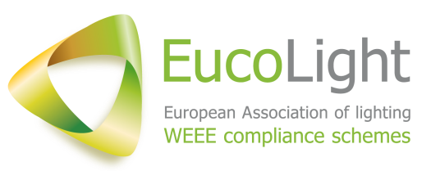
Press Release

Circular Economy Package: EucoLight calls on the European Institutions to secure clear and binding extended producer responsibility (EPR) requirements

30 June 2017

The final step of the adoption of the EU Waste legislative package is in the informal Trilogue phase. The European Parliament, the Council and the European Commission are finalising the text of the proposal to amend the Directive on Waste. This proposal includes minimum extended responsibility requirements.

EucoLight has been advocating for legally binding minimum requirements in the EU law throughout the whole legislative process. Extended producer responsibility is indeed one the most successful tools of the EU’s Waste management policy, and key to the success of the Circular Economy approach.

The inclusion of minimum EPR requirements in the EU law offers a wealth of opportunities to ensure the best functioning of EPR schemes in the Member States. It remains that, at this point of time, some limited but essential key points need still to be properly addressed:
- Adding distributors to the list of all actors involved in EPR will contribute to the best and fair management of EPR schemes and compliance at all levels;
- Having clearly defined producers’ financial obligations that do not go beyond their field of responsibility, will ensure transparency and proper financing of waste management;
- Establishing a stakeholder platform will facilitate the exchange of good practices through the EU and can contribute to the sound enforcement of EPR;
- Ensuring that EPR organisations do not own recycling contractors will guarantee that free market mechanisms are not disrupted.

- ENDS -

About EucoLight:

EucoLight is The European association of collection and recycling organisations for WEEE lamps and lighting. On behalf of its 19 members, EucoLight engages with everything related to the WEEE Directive, legislations and standards affecting the collection and recycling of WEEE lighting. EucoLight members collect and recycle, in aggregate, 79 % of the lamps waste collected in the 18 countries in which they operate.

EucoLight is the voice of European WEEE compliance schemes specialised in managing the collection and recycling of WEEE lighting; working to make the circular economy a reality for lighting products.
Founded mid-2015, EucoLight has quickly embarked into constructive dialogue with relevant stakeholders to provide expertise in the field of management and treatment of WEEE lighting and to promote the positive role of Extended Producer Responsibility schemes on the environment and society.
For more information, visit the EucoLight website www.eucolight.org, follow EucoLight on Twitter @EucoLight or contact the Secretary General, Marc Guiraud (marc.guiraud@eucolight.org).

